Mummy’s Restaurant Online Order System

Introduction
Mummy’s restaurant is predominantly an Indian cuisine restaurant based in the UAE. Mummy’s restaurant allows its customers to order their meals online. Mummy’s restaurant offers a wide variety of Indian cuisine. Mummy’s restaurant provides its customers with the option of ordering any meal of the day online for a period of 30 days providing them delivery service and modifiable delivery dates and address. Thus proves to be an aid to the working professionals allowing them to order meals at their work place or at home.

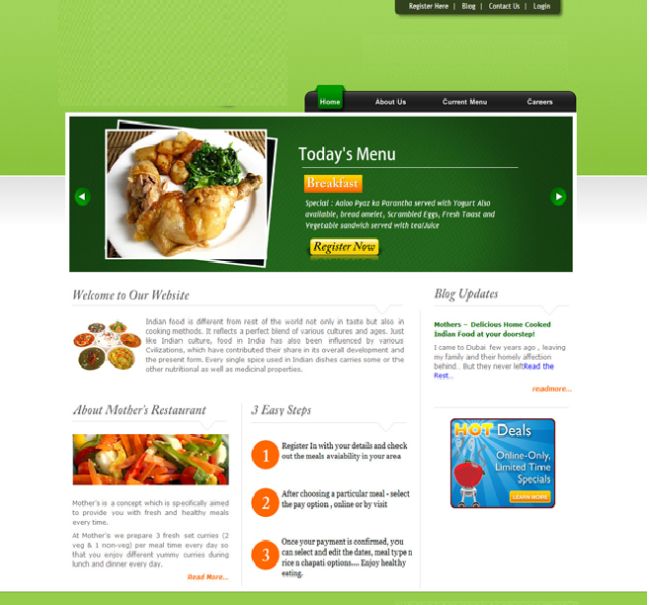

Visitor’s View
- A website through which a customers could order Indian meals online. The web application should have a product gallery of various meals and packages offered by Mummy’s restaurant.
- Costumers would first have register and login to place their orders.
- Customers could select the meal option from the menu, containing description about the delicacies on offer and price.
- Each meal would have options such as modification in delivery address, date and the choice of package.
- User could select desired meal type i.e. veg. or non-veg. and would have to provide required Delivery date, Delivery time. The website also gives the option of modifiable dates if the person is leaving for a vacation.

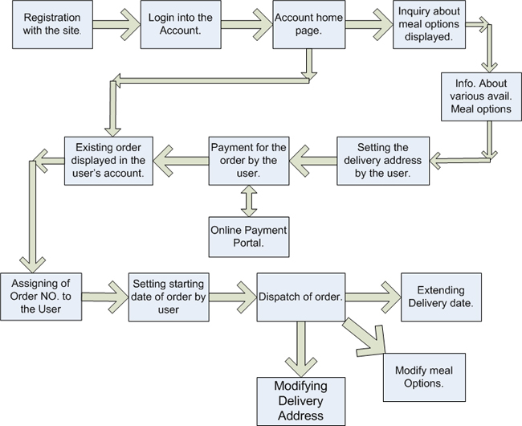

- User then has to set the starting date of the order.

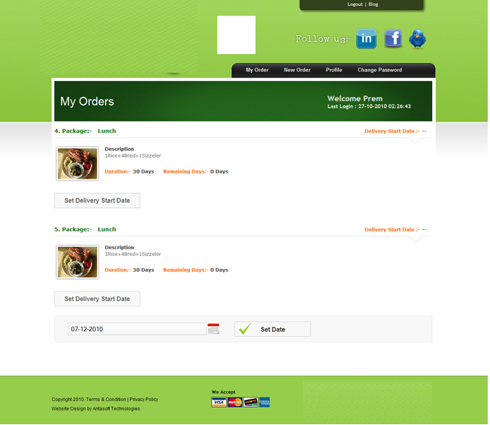
Administrator’s View:-
- Login
- The admin is required to login into the account to make required changes or modification as desired to manage.
- Today’s management
- Today’s management includes view of orders queued for the day .Includes detailed view of order type, area and menu.
- It also includes an option where the admin could modify the menu or add specialties for the day.
- User management
- User management includes the option provided to the user to delete, ban or enable any user registered with the site.
- Admin also has the option for changing the password of the user if admin desires to do so.
- Area management
- Area management provides admin the option of editing, deleting or adding and area to provide service in.
- Area management also allows to modify packages available in a specific area.
- Package management
- Package management involves creation of new package or managing existing package.
- It also contains the option of modifying time slots for availability of packages in a certain area.
- Order management
- Order Management enables the admin to view orders according to mode of payment i.e. by cash on delivery/visit or online payment.
- Order Management also enables the admin to view orders categorized according to date , area ,name ,email id ,order no..

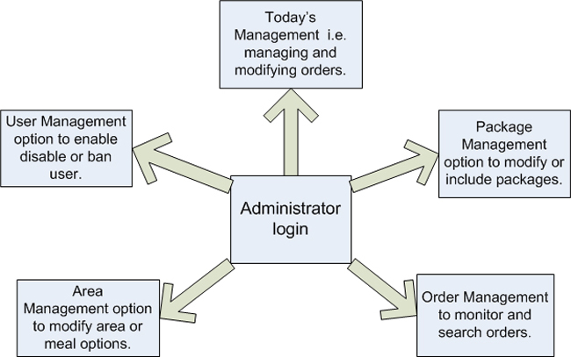

- Today’s Management

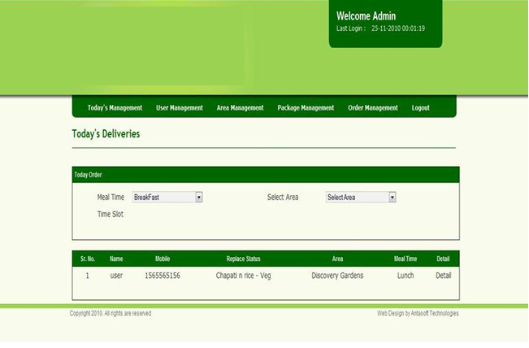

- Area Management
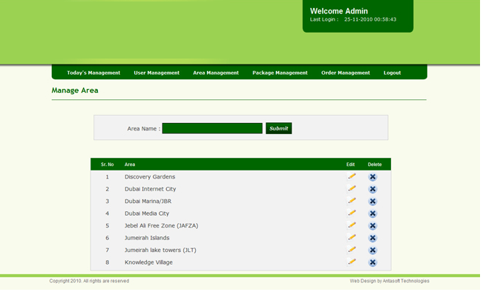
- Package Management
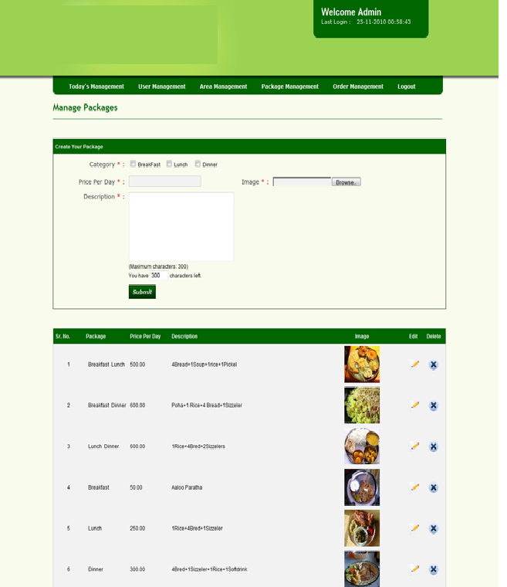

- Order Management
